**Лабораторная работа №5**

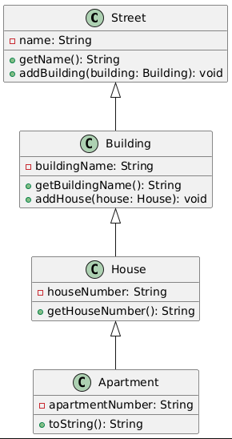

**Рисунок 1** – Иерархия улицы

***Код:***

@startuml

class Street {

- name: String

+ getName(): String

+ addBuilding(building: Building): void

}

class Building {

- buildingName: String

+ getBuildingName(): String

+ addHouse(house: House): void

}

class House {

- houseNumber: String

+ getHouseNumber(): String

}

class Apartment {

- apartmentNumber: String

+ toString(): String

}

Street <|-- Building

Building <|-- House

House <|-- Apartment

@enduml